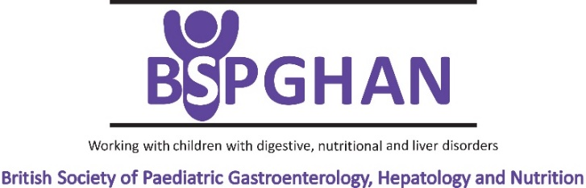 | 

RESEARCH SCOPE AND ELIGIBILITY CRITERIA FOR THE ‘GUTS UK-BSPGHAN GRANTS’

Every two years Guts UK and The British Society of Paediatric Gastroenterology, Hepatology and Nutrition (BSPGHAN) co-fund a grant call for research studies on paediatric gastrointestinal, hepatological and nutritional disorders.
On 24th April 2025 both organisations are opening a new call to award two grants up to £40,000 each. The closing date to submit applications is Monday 30th June 2025 at 5pm.

Research scope:
Guts UK and BSPGHAN are inviting applications for research studies on any topic within the spectrum of paediatric gastroenterology, hepatology and nutrition.
These awards are envisaged as development grants for the collection of pilot or proof-of-concept data that will enable a high-quality competitive application to be made subsequently to a research council or other large funder, such as the National Institute of Health Research.

Eligibility criteria:
The grant call is open to clinician and scientist investigators, including Academic Clinical Lecturers, based at a UK university or hospital. The principal applicant must have a contract of sufficient length to cover the duration of the research project. At the time of applying the principal applicant must have their salary guaranteed for the entire period of the research project. This award is not for a fellowship; the principal applicant must not be a fellow though co-applicants may be. Funding will be available only in the UK.

Budget and research duration:
The maximum allowed budget per grant is £40,000. Only the direct costs associated with the project will be funded. Overhead allocation or other indirect costs, and salary of applicants which are already covered by other funding, will not be allowed. Equipment or capital costs will not be funded either. The maximum duration of the projects should be 24 months.

Other considerations:
Guts UK are keen that the research starts as soon as possible, and it is expected that the research project will start within 6 months of the award date. Ethical approval, if required by the project, will be needed before the work commences. All licences pertaining to research using animals must be valid and in place.
Provided the study meets the NIHR’s definition of a ‘research study’, the selected project(s) will also be eligible for adoption by the UK Clinical Research Network and therefore will be eligible for NIHR support. For clinical research proposals, applicants are encouraged to contact their local NIHR Clinical Research Network for advice as early as possible.

Application process:
An application form and guidance notes for completing the form can be downloaded from the Guts UK website.
Please submit your fully e-signed application by email to research@gutscharity.org.uk (including copies of supporting letters/emails). The deadline for applications will be Monday 30th June 2025 at 5pm.

Applications will be assessed for plausibility, feasibility, importance, originality, suitability of research team, as well as for the potential to elicit clinically useful results, further funding and/or follow up studies. Applications will be initially scored by representatives from the Guts UK Research Awards Committee and from BSPGHAN Research Group. The top scoring applications will be sent for external peer review. These applications, and their external reviews, will be assessed by a joint panel made up from a subset of the Guts UK Research Awards Committee and BSPGHAN representatives. This panel will then select up to two research projects for funding and the Trustees of Guts UK will approve the awards of the grants to those research projects. The successful applicant will be notified in December 2025.
If you have any questions about the application procedure, please e-mail: research@gutscharity.org.uk
Please note: Any queries relating to submission of the application must be referred directly to Guts UK. Applicants or their colleagues may not contact a Guts UK Research Awards Committee member, BSPGHAN representative or a Trustee of Guts UK to discuss any aspect of an application or the decision reached on it.
These grants will be bound by the Guts UK terms and conditions, as well as by any special conditions relevant to the grant call. For details of the Guts UK terms and conditions of grants please see the website.

