guts
UK
Candidate Pack

FUNDING RESEARCH TO
FIGHT DISEASES OF THE
GUT, LIVER & PANCREAS

Treasurer
Trustee

January 2020

gutscharity.org.uk
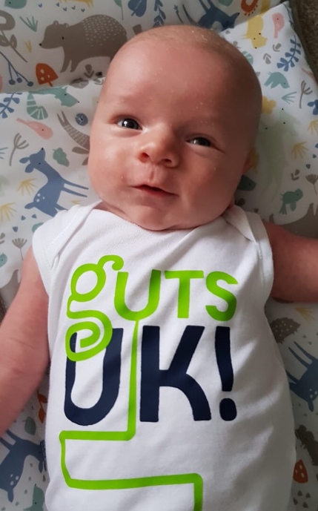
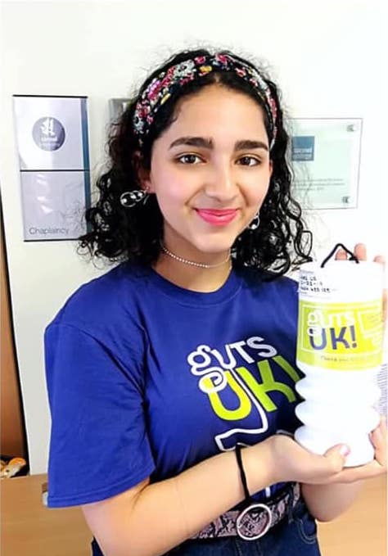
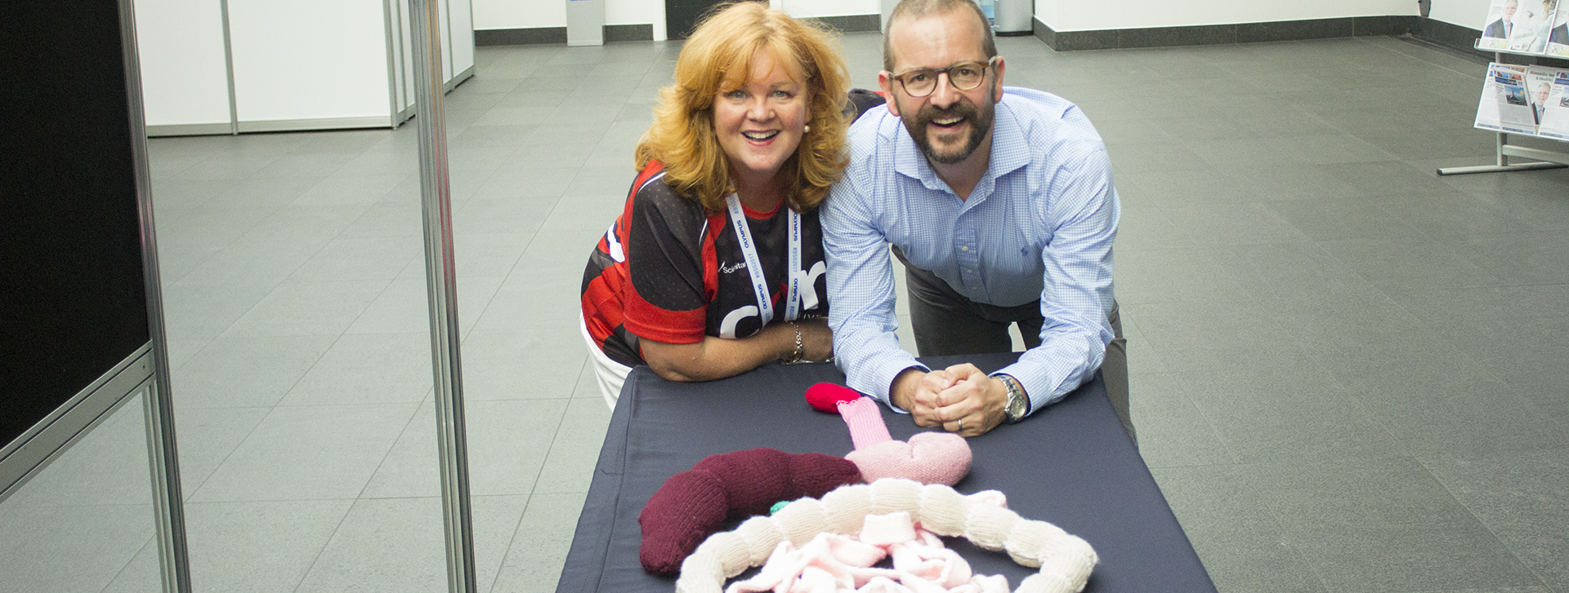
Dear Applicant,
I am delighted that you are interested in joining our board of trustees. These are challenging but rewarding times for charities. We actively support the legislation that regulates charities effectively and welcome support and advice from committed individuals from a wide range of backgrounds to help with this important responsibility.
Guts UK has set about an ambitious journey of growth and transformation built on a rich and robust past investment of more than £15 million in research into gastroenterology. As the only UK charity dealing with all aspects of gastrointestinal, liver and pancreatic health and disease, we know this is a vast field to cover. We feel we have a responsibility to bring other charities with us to deliver greater impact and to reverse the shortfall of funding for digestive health. This will require ambition matched with diplomacy, but we can point to real progress in collaborations so far and achieving this shared vision.
The charity enjoys committed support from medical trustees who are active as consultants and in research of their own. Our lay trustees are an invaluable source of skill and wisdom, without whom we would struggle. The new charity landscape means we need these skills more than ever. There is no better time than now for committed individuals to become actively involved trustees. I hope you see joining at this exciting time as an opportunity that can bring immense personal satisfaction.
So we thank you for your interest. If there are any points in this document that you would like to clarify please don’t hesitate to get in touch.

Professor Jonathan Rhodes,
Chair of Trustees

FUNDING RESEARCH TO
FIGHT DISEASES OF THE
GUT, LIVER & PANCREAS
gutscharity.org.uk
About Guts UK charity
Previously known as Core, Guts UK is the only medical research charity that covers all digestive conditions of the gut, liver and pancreas, from top to tail. Guts UK is uniquely placed as the sister charity of the British Society of Gastroenterology – the digestive health of the nation is in their hands.
We launched our new name and rebranded mission as Guts UK in June 2018 with a commitment to growing a digital platform to improve accessibility, profile and reach. Just 18 months later we have a 900% uplift in traffic to our website and 100 new sign-ups per week for our newsletter. Guts UK aims to serve people affected and be the voice for those who feel their digestive condition is not understood or taken seriously enough.
Guts UK understands the importance of healthy guts. If the gut works, life works. We are fascinated with the workings of “the inner tube of life” and by bringing the urgency of the patients’ need alongside the expertise of health professionals, together we can understand more and help others.
Our proposition: Don’t take your guts for granted
We believe it’s time for the guts to have their day. Our guts just don’t get the attention they deserve. The better we understand how it all works, the better we can look after our insides.
It is estimated that digestive disorders account for 12 % of all NHS resources, from GPs through to specialist consultants. It affects huge numbers of people, every day.
Guts UK can help people affected by gut disorders get the right information, empowering them to ask the right questions for a quicker diagnosis, treatments and effective self-management.

Research into our guts is woefully underfunded and has been for decades.
We should rival levels of investment into heart and cancer research but alas, we are way short of this. How come the guts got left behind? There are too many unanswered questions and too many conditions that lack effective treatments. We need to be a charity investing £10 million a year to make the kind of impact needed by society and, whilst this is an ambitious goal, we are already on the right track.
Our plans
Guts UK has embarked upon an ambitious journey of transformation and growth. Transitioning from an inward looking research-based organisation to a public facing repository of knowledge, a network of experts and a proactive community, Guts UK aims to become the central charity and research organisation promoting and educating the public about the importance of a healthy gut.

- Guts UK intends to tackle the stigma surrounding gut health

- This role is key to leading our stakeholder groups to deliver a successful income growth strategy for 2020 – 2022 to maximise the opportunity of celebrating 50 years of the charity in June 2021.

- Delivering our charitable objectives with measurable impact, we will create a strong sense of direction, focus and clarity.

- The journey of bringing together different stakeholders, creating a new culture at Guts UK, is as important as the final outcome and will be the platform for delivering the strategy.

- Our aim is that by June 2021 when the charity will be 50 years old, we should be a charity that is recognised as the ‘go to’ place for anyone affected by digestive conditions with a growing income of £5 million a year instead of £500,000.

Guts UK are now actively putting the patients and people affected by issues surrounding digestive health at the centre of our mission. We conducted research with patients and carers to understand how their lives were affected by digestive health issues. Their contributions were incredibly personal, honest, brave and bold. We have adopted these values and the new name; a dynamic, bold, ‘say-what-it-does-on-the-tin’ Guts UK.

Board of Trustees
The current board of trustees is composed of 7 medical experts including our Chair, 5 clinicians, a nutritionist and 4 lay trustees bringing expertise in the roles of Treasurer, Digital, Marketing and Legal trustees.

Whilst the current trustees are dedicated experts in their field, in order to succeed with our ambitious plans, Guts UK now needs more balance in terms of business development and income generation skills. Our current treasurer has completed his term of office and we are looking to recruit his replacement for 2020 – 2023, a very exciting period for the charity.

Subcommittees
As part of Guts UK’s governance structure, trustees will contribute to the appropriate subcommittee meetings. There is an active Audit, Risk and Compliance Subcommittee lead by the Treasurer and a recently formed Research Strategy Group.
In addition, the formation of a Fundraising and Strategy has begun and it is envisaged that a new Business Development Trustee also being actively recruited will lead this sub committee.
Finances
Find out more about Guts UK Finances
Guts UK Finance Trustee
Role Summary
Charity governance is a balanced relationship between the employed executive staff (Chief Executive, Finance Manager, Research Manager, etc) and the volunteers on board of trustees. This team is responsible for directing the affairs of a charity, ensuring that it remains solvent, well-managed, and delivering on the stated charitable objectives.
A key role in the effective governance of most charities is that of the Treasurer. While financial matters are the responsibility of all trustees, it is often the Treasurer that the other trustees look to for all aspects of the charity’s financial management and governance. In overview, the Treasurer is responsible for:
- Establishing and maintaining a robust financial governance framework
- General financial oversight
- Financial planning and budgeting
- Financial compliance and reporting, including audits
- Banking, book-keeping, financial reconciliations and controls
- Control of fixed assets and stock
Given these responsibilities, the Treasurer typically acts as an information and reference point for the Chair and other committee members: clarifying financial implications of proposals; confirming legal requirements; outlining the current financial status; and retrieving relevant documentation.
Main Tasks
- Overseeing and presenting budgets, internal management accounts and annual financial statements to the board of trustees;
- Taking the leading role for the board in ensuring proper accounting records are kept, audited annual financial statements are produced, financial resources are properly controlled, invested and economically spent, in line with good governance, legal and regulatory requirements;
- Providing guidance and advice to the Finance Manager responsible for the financial activities of the organisation;
- Chairing Guts UK’s Audit, Regulatory and Compliance (ARC) committee ensuring proper meetings are held to review and oversee the operation of the charity in line with its terms of reference, and reporting back to the board of trustees;
- Monitoring and advising on the financial viability of the charity;
- Overseeing the development and implementation of appropriate financial systems and controls;
- Advising on the financial implications of the charity’s strategic plan;
- Overseeing the charity’s financial risk‐management process, including developing new policy and processes to manage developing risks as appropriate;
- Providing direct controls over certain finance outflows as counter signatory on charity payments and significant transactions where required;
- Representing the board liaising with the external auditors and oversee the audit of the annual financial statements and controls
Person Specification:
Essential
- A qualified Accountant with good understanding and appreciation of corporate governance and financial management.
- Appreciate the role and can deal effectively with auditors, regulators, HMRC, investment managers, banks and other institutions
- Have good interpersonal skills and an effective communicator at senior level
- Highest level of integrity.
- Be able to see the big picture yet have an eye for the details and experience with dealings with large sums
- Be methodical and able to act decisively in the face of ambiguities
- Work effectively as part of a team
Desirable
- Have people management experience
- Understand and have experience of investments
- Good IT skills
- Have appreciation of the legal requirements of a charity including its regulatory environment
Impact of the role
Our mission is to expose and address the stigma surrounding digestive health whilst educating and informing the public on the importance of the issue. Having excellent financial governance allows the charity to safeguard its assets and protect its operations ensuring the highest level of compliance in order to continue delivery on its objectives. The Treasurer is instrumental in ensuring Guts UK remains compliant with all its regulatory requirements and have robust financial governance, as well as providing expert guidance to the other trustees, the CEO and Finance Manager as part of the Audit, Risk and Compliance committee.
What’s in it for the volunteer
As part of the Board, the Treasurer will be exposed and be expected to provide advice and guidance to the rest of the Board on all financial matters. This provides a sound basis to develop interpersonal and communication skills at the highest level of management. With the comprehensive oversight responsibilities as part of the Audit, Risk and Compliance committee ranging from strategic, financial, legal, investment, HR, IT and operational matters, the Treasurer will be able to develop a broad range of experience to further enhance his/her leadership capabilities.
Time Commitment and Location
On average, it is estimated that this role will require 10-12 hours per month.
Trustees of Guts UK are expected to attend four board meetings per year with some strategy days taking place in-between. Trustees will be expected to contribute to appropriate subcommittee meetings and be available on an ad hoc basis depending on the needs of the charity.
Board meetings currently take place in central London but it is hoped that, as a national charity, a proportion of Guts UK board meetings will eventually take place elsewhere in the country.
How to apply
To apply, please submit your CV along with a covering letter stating why you wish to join Guts UK’s board, how your skills would add value to the board and any other relevant information.
Applications must be submitted for the attention of CEO Julie Harrington in the first instance jharrington@gutscharity.org.uk by February 1st 2020.
If you are interested and would like to talk to someone about the role before applying, don’t hesitate to contact Julie directly on 07809 904150. If you would like to have a preliminary phone call with our Chair, please do let us know and we will be happy to arrange this for you.

