guts
UK
Candidate Pack

FUNDING RESEARCH TO
FIGHT DISEASES OF THE
GUT, LIVER & PANCREAS

Business Development
Trustee

January 2020

gutscharity.org.uk
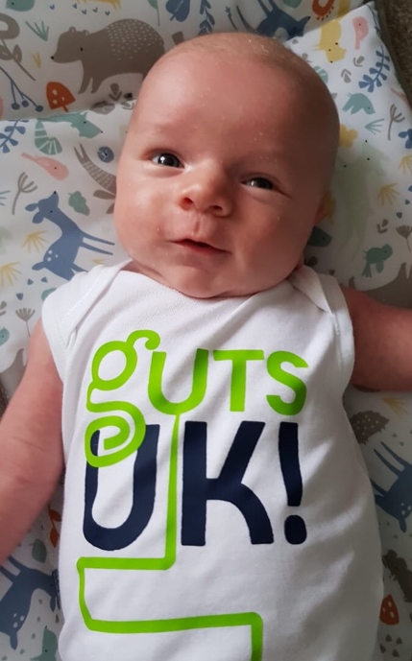
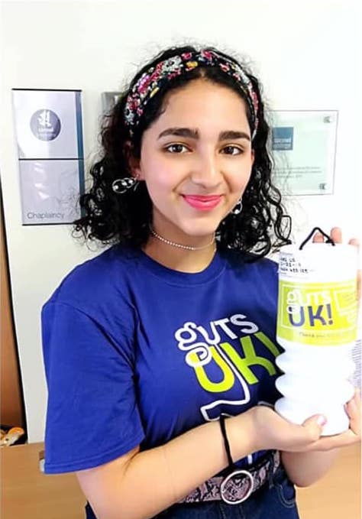
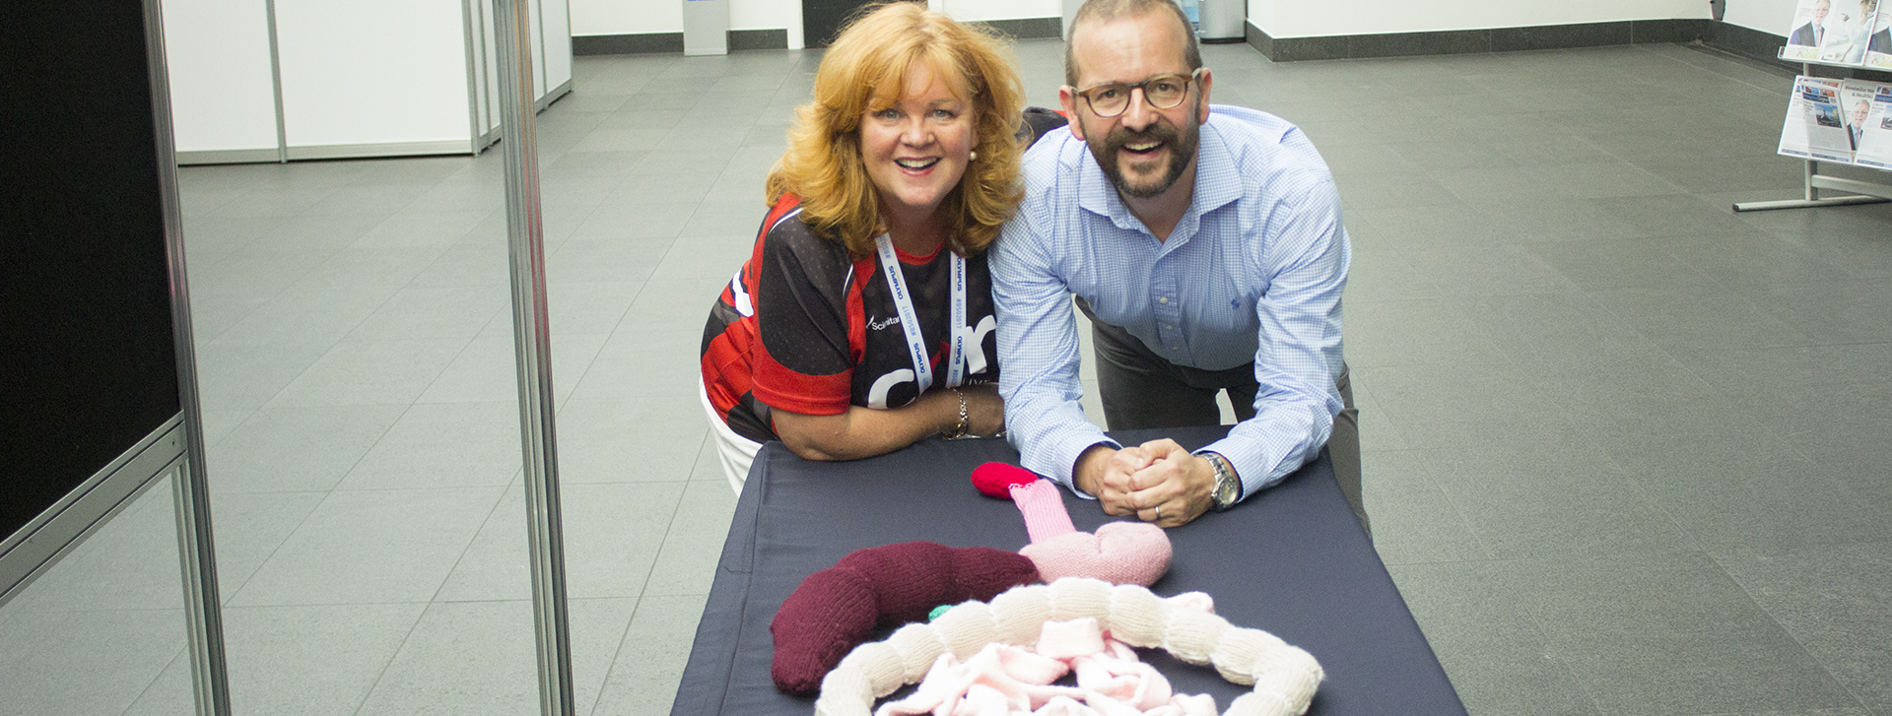
Dear Applicant,
I am delighted that you are interested in joining our board of trustees. These are challenging but rewarding times for charities. We actively support the legislation that regulates charities effectively and welcome support and advice from committed individuals from a wide range of backgrounds to help with this important responsibility.
Guts UK has set about an ambitious journey of growth and transformation built on a rich and robust past investment of more than £15 million in research into gastroenterology. As the only UK charity dealing with all aspects of gastrointestinal, liver and pancreatic health and disease, we know this is a vast field to cover. We feel we have a responsibility to bring other charities with us to deliver greater impact and to reverse the shortfall of funding for digestive health. This will require ambition matched with diplomacy, but we can point to real progress in collaborations so far and achieving this shared vision.
The charity enjoys committed support from medical trustees who are active as consultants and in research of their own. Our lay trustees are an invaluable source of skill and wisdom, without whom we would struggle. The new charity landscape means we need these skills more than ever. There is no better time than now for committed individuals to become actively involved trustees. I hope you see joining at this exciting time as an opportunity that can bring immense personal satisfaction.
So we thank you for your interest. If there are any points in this document that you would like to clarify please don’t hesitate to get in touch.

Professor Jonathan Rhodes,
Chair of Trustees

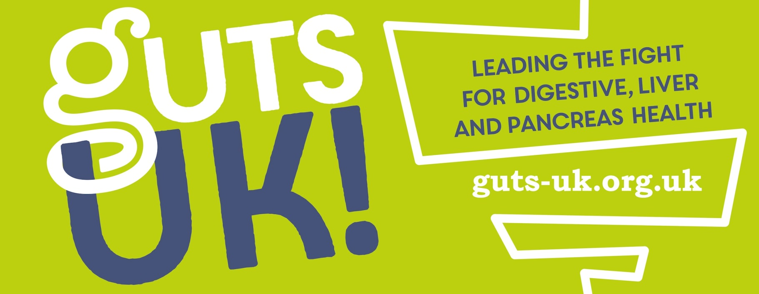
FUNDING RESEARCH TO
FIGHT DISEASES OF THE
GUT, LIVER & PANCREAS
gutscharity.org.uk
About Guts UK charity
Previously known as Core, Guts UK is the only medical research charity that covers all digestive conditions of the gut, liver and pancreas, from top to tail. Guts UK is uniquely placed as the sister charity of the British Society of Gastroenterology – the digestive health of the nation is in their hands.
We launched our new name and rebranded mission as Guts UK in June 2018 with a commitment to growing a digital platform to improve accessibility, profile and reach. Just 18 months later we have a 900% uplift in traffic to our website and 100 new sign-ups per week for our newsletter. Guts UK aims to serve people affected and be the voice for those who feel their digestive condition is not understood or taken seriously enough.
Guts UK understands the importance of healthy guts. If the gut works, life works. We are fascinated with the workings of “the inner tube of life” and by bringing the urgency of the patients’ need alongside the expertise of health professionals, together we can understand more and help others.
Our proposition: Don’t take your guts for granted
We believe it’s time for the guts to have their day. Our guts just don’t get the attention they deserve. The better we understand how it all works, the better we can look after our insides.
It is estimated that digestive disorders account for 12% of all NHS resources, from GPs through to specialist consultants. It affects huge numbers of people, every day.
Guts UK can help people affected by gut disorders get the right information, empowering them to ask the right questions for a quicker diagnosis, treatments and effective self-management.

Research into our guts is woefully underfunded and has been for decades.
We should rival levels of investment into heart and cancer research but alas, we are way short of this. How come the guts got left behind? There are too many unanswered questions and too many conditions that lack effective treatments. We need to be a charity investing £10 million a year to make the kind of impact needed by society and, whilst this is an ambitious goal, we are already on the right track.
Our plans
Guts UK has embarked upon an ambitious journey of transformation and growth. Transitioning from an inward looking research-based organisation to a public facing repository of knowledge, a network of experts and a proactive community, Guts UK aims to become the central charity and research organisation promoting and educating the public about the importance of a healthy gut.

- Guts UK intends to tackle the stigma surrounding gut health

- This role is key to leading our stakeholder groups to deliver a successful income growth strategy for 2020 – 2022 to maximise the opportunity of celebrating 50 years of the charity in June 2021.

- Delivering our charitable objectives with measurable impact, we will create a strong sense of direction, focus and clarity.

- The journey of bringing together different stakeholders, creating a new culture at Guts UK, is as important as the final outcome and will be the platform for delivering the strategy.

- Our aim is that by June 2021 when the charity will be 50 years old, we should be a charity that is recognised as the ‘go to’ place for anyone affected by digestive conditions with a growing income of £5 million a year instead of £500,000.

Guts UK is now actively putting the patients and people affected by issues surrounding digestive health at the centre of our mission. We conducted research with patients and carers to understand how their lives were affected by digestive health issues. Their contributions were incredibly personal, honest, brave and bold. We have adopted these values and the new name; a dynamic, bold, ‘say-what-it-does-on-the-tin’ Guts UK.

Board of Trustees
The current board of trustees is composed of 7 medical experts including our Chair, 5 clinicians, a nutritionist and 4 lay trustees bringing expertise in the roles of Treasurer, Digital, Marketing and Legal trustees.

Whilst the current trustees are dedicated experts in their field, in order to succeed with our ambitious plans, Guts UK now needs more balance in terms of business development and income generation skills.

Subcommittees
As part of Guts UK’s governance structure, trustees will contribute to the appropriate subcommittee meetings. At present, there is an Audit, Risk and Compliance Subcommittee and a recently formed Research Strategy Group.
In addition, the formation of a Fundraising and Strategy has begun and it is envisaged that the new Business Development Trustee will lead this team
Find out more about Guts UK Finances – click here
Business Development Trustee
Role Summary
As with most charities in the current financial climate, income generation poses a challenge to Guts UK. Whilst the organisation is in a strong position financially, our plans for growth and development will require us to look carefully at our business model. As with most charities, we are interested in developing new avenues of funding through grant-giving organisations and high-net worth donors, however, we are equally keen to explore the possibilities presented by corporate engagement, partnerships and collaborations. For this reason, we are looking for someone who can see the bigger picture when it comes to income generation.
The business development trustee will play an important, entrepreneurial role within the trustee board, scoping out opportunity and seeking to make connections between Guts UK and other public, private, charitable and academic organisations.
Role Summary
To assist the Board to develop a corporate relationship strategy and to build links with charities, public sector bodies, academic institutions, companies and businesses to help achieve Guts UK’s Mission.
Main Tasks
- To assist the Board and senior staff in developing a fundraising and income generation strategy and action plan.
- To oversee ideas and areas for corporate and business support to Guts UK.
- To develop a complete picture of possible sources of income available to Guts UK and to prioritise and develop ways in which to secure funding.
- To strategically assess where corporate and business fits into the overall organisation strategy and to work with senior staff to ensure effective partnership activities are achieved.
- To contribute knowledge of businesses and companies to Guts UK activities.
- To develop contacts with businesses, companies and grant giving organisations to assist fundraising and income generation.
- To make the ‘business case’ for companies and businesses to partner with Guts UK.
- To identify proposals for business and company partnerships in conjunction with senior staff.
- To network on behalf of the charity to solicit sponsorship, funds and resources on a peer to peer basis.
- To be an active champion of the organisation.

Person Specification:
A background in any of the following areas: - Corporate Social Responsibility, Corporate Partnerships, Company Sponsorships, Business Development, Enterprise, Change Management, Fundraising, Bid Writing, High Net-worth donors.
Essential
- A good understanding of business and companies and how they can support charitable activities.
- A good understanding of sponsorship and other resource generation opportunities and business development.
- Good experience and knowledge of corporate and business partnerships with charities and/or social enterprise business development background and/or having run a medium size business.
- An understanding of the challenges facing small to medium UK charities in making links with donors, businesses and companies.
- Experience at senior level in having run a successful business and demonstrable entrepreneurial expertise.
- Excellent networking, influencing and communication skills.
Desirable
- High level knowledge and contacts within business.
- Knowledge of the charity and voluntary sector and/or social enterprise.
- An understanding of the UK charity sector, good governance, Charity Commission, Companies House requirements, relevant legislations and statutory requirements.
Impact of the role
Our mission is to expose and address the stigma surrounding digestive health whilst educating and informing the public on the importance of the issue. We believe that there are many organisations and companies whose corporate aims could dove-tail with this mission. We aim to transform Guts UK into the leading gastric health charity in the sector but we can’t do this without the financial and strategic support of key partners. These may include corporate, academic institutions, other charities and public entities all of which need to be engaged tactfully. Given the context of reducing NHS and Local Council support due to budgetary constraints, the business development trustee will work closely with the digital and marketing trustees to ensure that our income generation strategy is holistic and carefully considered.
What’s in it for the volunteer
A huge part of our challenge will be finding the best ways to finance and develop our new outward facing approach. Much of our success will rest on being able to secure a strong backbone of sustainable, core funding with which we can develop our website, create additional capacity to deliver and to scale up our impact. The business development trustee will be at the heart of this process, leveraging their expertise and connections for a fantastic cause. In addition to this, you will work with a committed board of trustees and an enthusiastic CEO with a strong fundraising and marketing background, all of whom are committed to driving change in this little understood and severely underfunded area of health care.
Time Commitment and Location
On average, it is estimated that this role will require 8 hours per month.
Trustees of Guts UK are expected to attend four board meetings per year with some strategy days taking place in-between. Trustees will be expected to contribute to appropriate subcommittee meetings and be available on an ad hoc basis depending on the needs of the charity.
Board meetings currently take place in central London but it is hoped that, as a national charity, a proportion of Guts UK board meetings will eventually take place elsewhere in the country.
How to apply
To apply, please submit your CV along with a covering letter stating why you wish to join Guts UK’s board, how your skills would add value to the board and any other relevant information.
Applications must be submitted for the attention of CEO Julie Harrington in the first instance jharrington@gutscharity.org.uk by February 1st 2020.
If you are interested and would like to talk to someone about the role before applying, don’t hesitate to contact Julie directly on 07809 904150. If you would like to have a preliminary phone call with our Chair, please do let us know and we will be happy to arrange this for you.

